**Dataset Visualization**

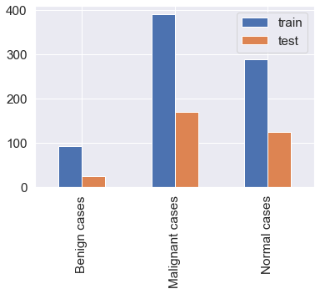

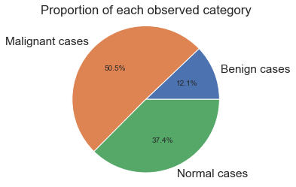

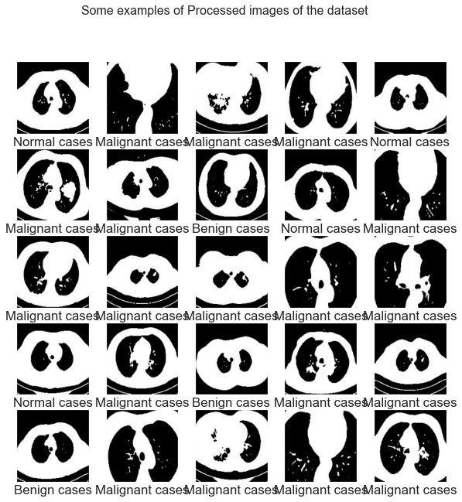

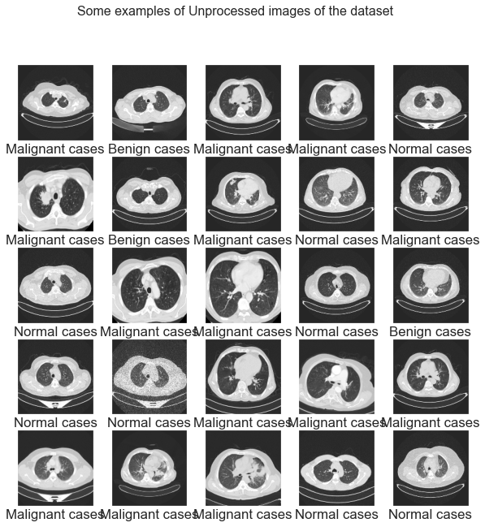

**Machine Learning approach**

**Accuracy Score comparison with Machine Learning approach**

|  |  |  |  |  |
| --- | --- | --- | --- | --- |
|  | **Accuracy Score for Processed Dataset** | **Accuracy Score for Without Processed Dataset** | **Accuracy Score for Vgg16 feature extraction with Processed Dataset** | **Accuracy Score for Vgg16 feature extraction Without Processed Dataset** |
| **Decision Tree Classifier** | 0.68 | 0.65 | 0.61 | 0.63 |
| **K-Nearest Neighbors Classifier** | 0.70 | 0.65 | 0.69 | 0.72 |
| **Logistic Regression Classifier** | 0.75 | 0.71 | 0.79 | 0.82 |
| **Naive Bayes Classifier** | 0.58 | 0.60 | 0.69 | 0.69 |
| **Random Forest Classifier** | 0.76 | 0.73 | 0.80 | 0.83 |
| **Support Vector Machine Classifier** | 0.77 | 0.73 | 0.80 | 0.88 |

**Machine Learning Image Classification**

**On Processed Dataset**

**Support Vector Machine on processed Dataset**

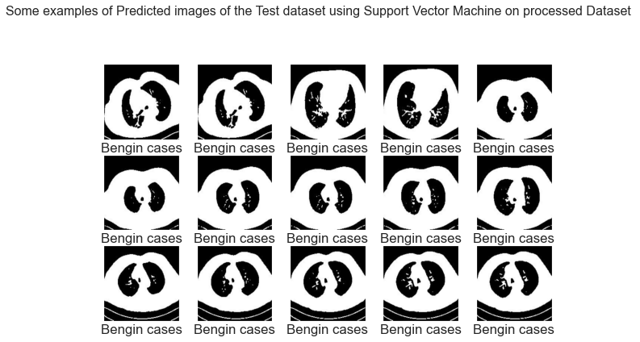



**Logistic Regression Classifier on processed Dataset**

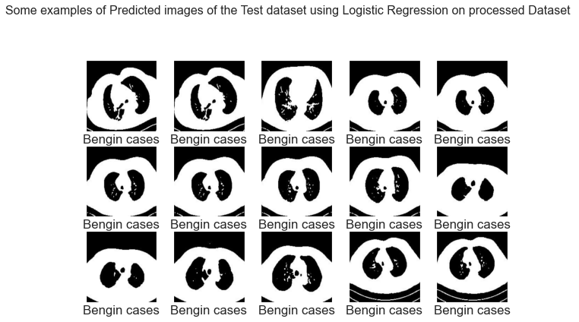

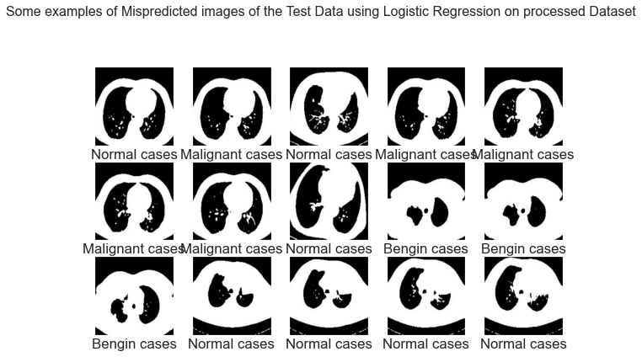

**Random Forest Classifier on processed Dataset**

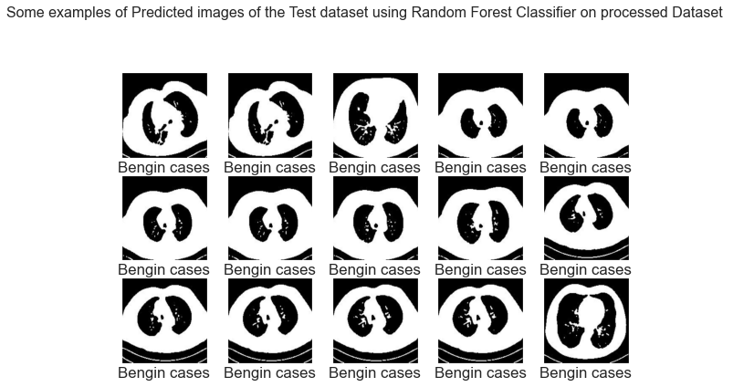

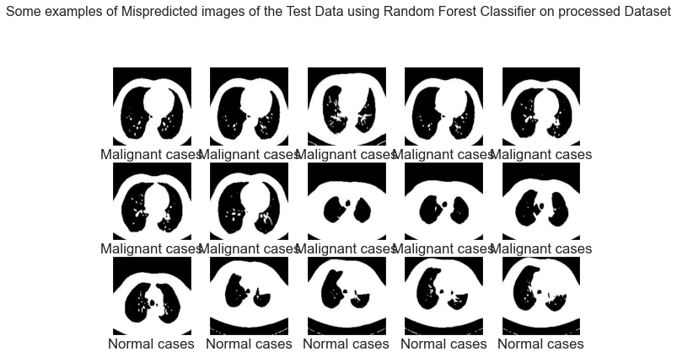

**On unprocessed Dataset**

**Support Vector Machine on Unprocessed Dataset**

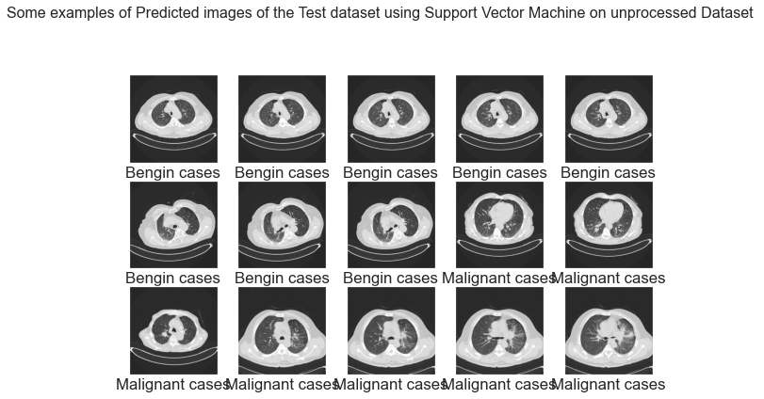

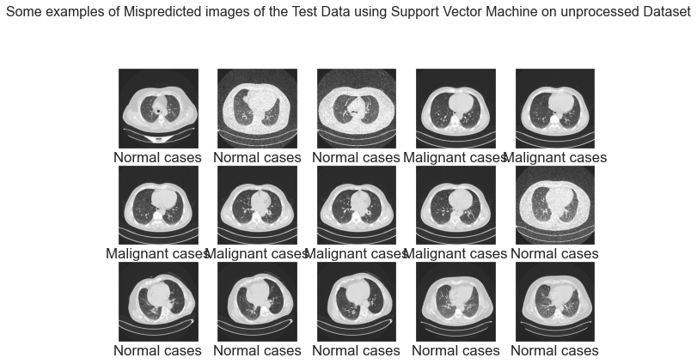

**Logistic Regression on unprocessed Dataset**

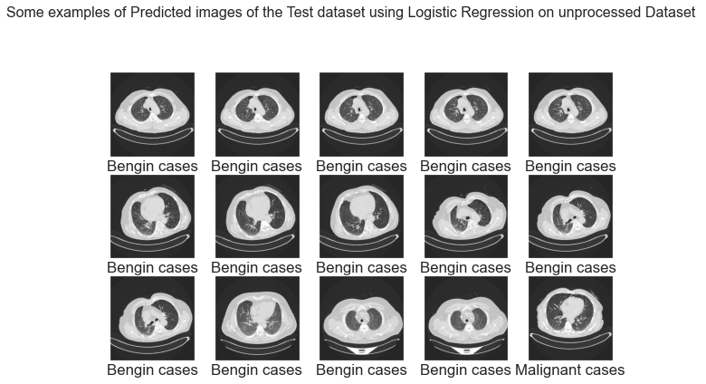

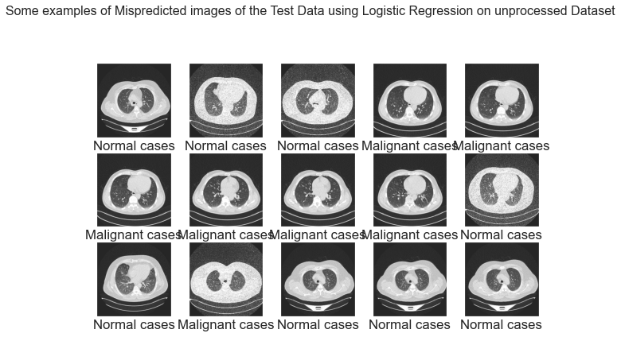

**Random Forest Classifier on unprocessed Dataset**

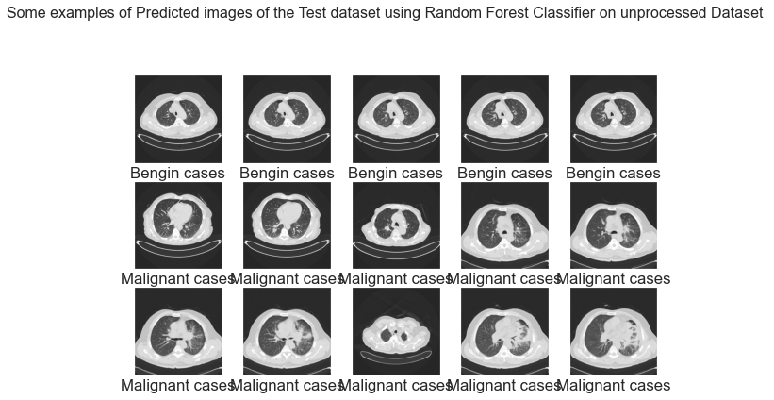

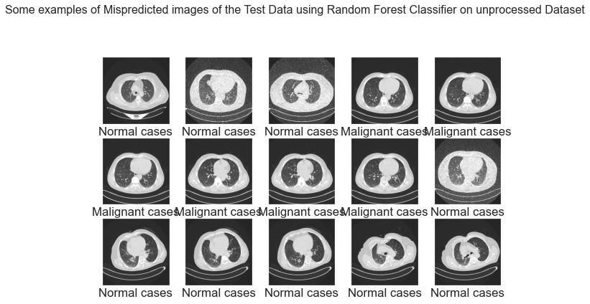

**Vgg16 feature extraction with Processed Dataset**

**Support Vector Machine on Vgg16 feature extraction with Processed Dataset**

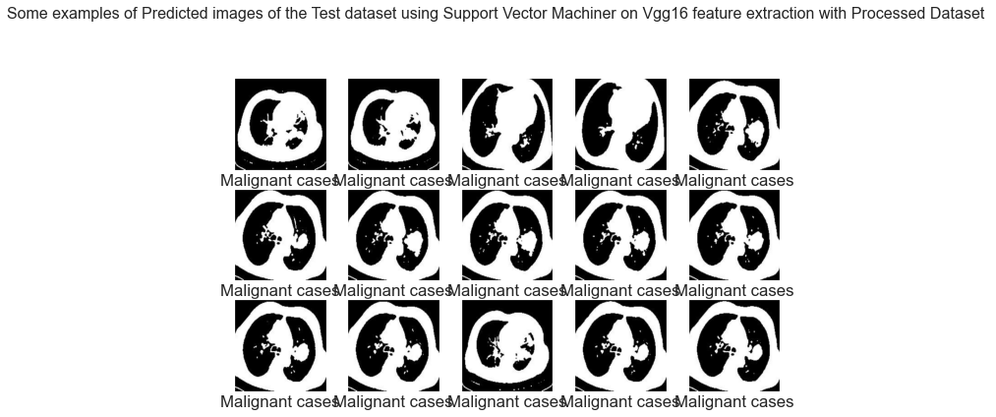

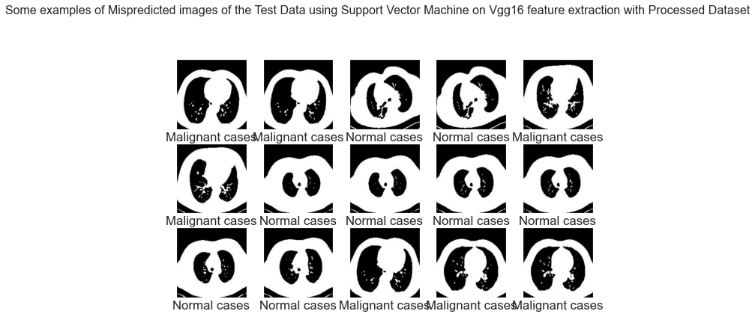

**Logistic Regression on Vgg16 feature extraction with Processed Dataset**

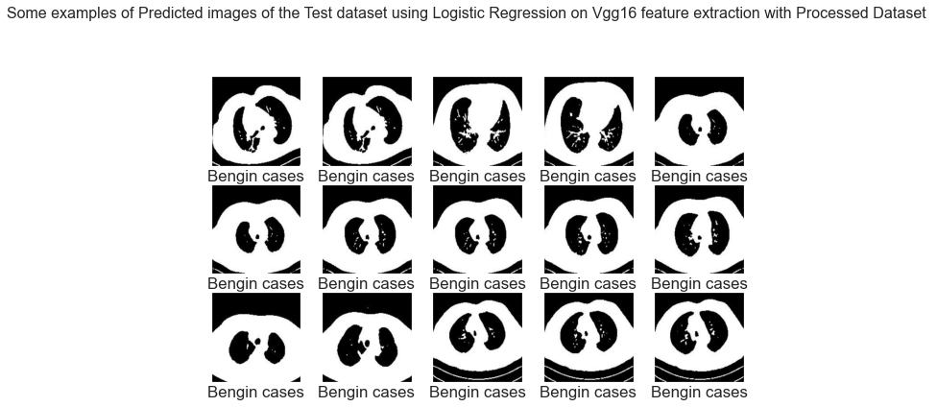

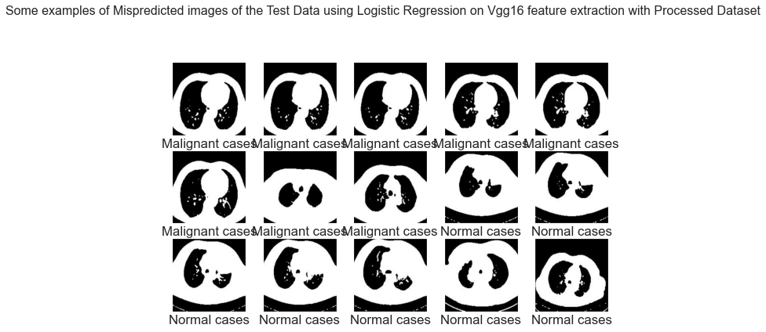

**Random Forest Classifier on Vgg16 feature extraction with Processed Dataset**

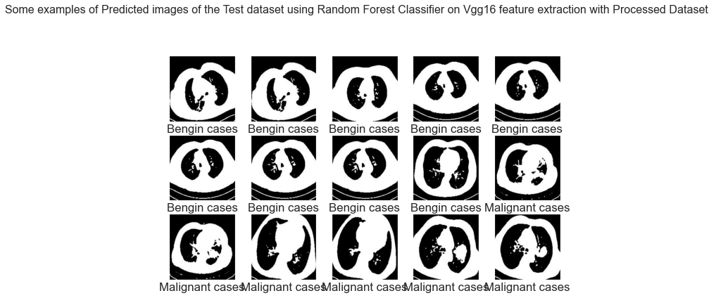

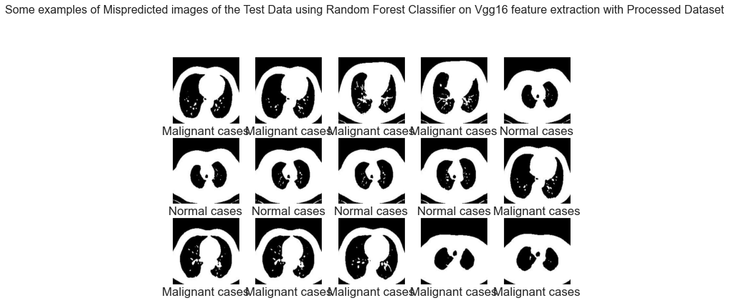

**Vgg16 feature extraction without Processed Dataset**

**Support Vector Machine on Vgg16 feature extraction without Processed Dataset**

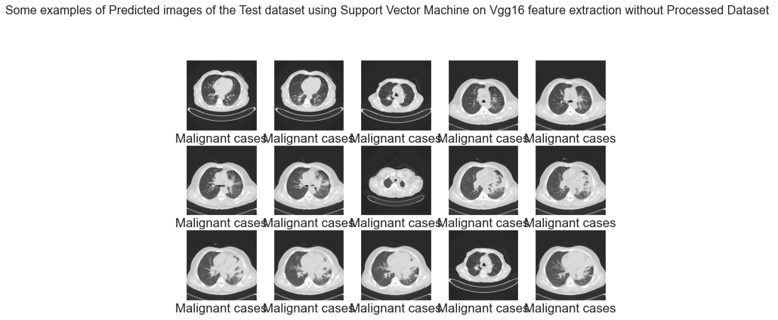

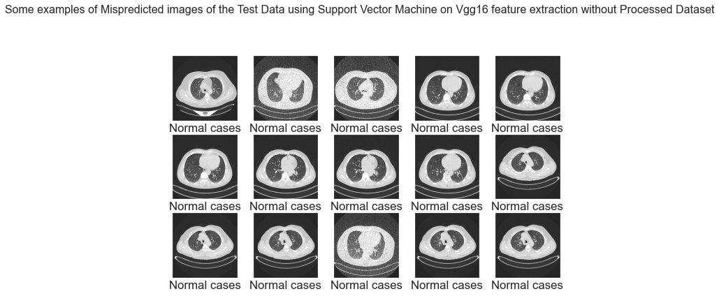

**Logistic Regression on Vgg16 feature extraction without Processed Dataset**

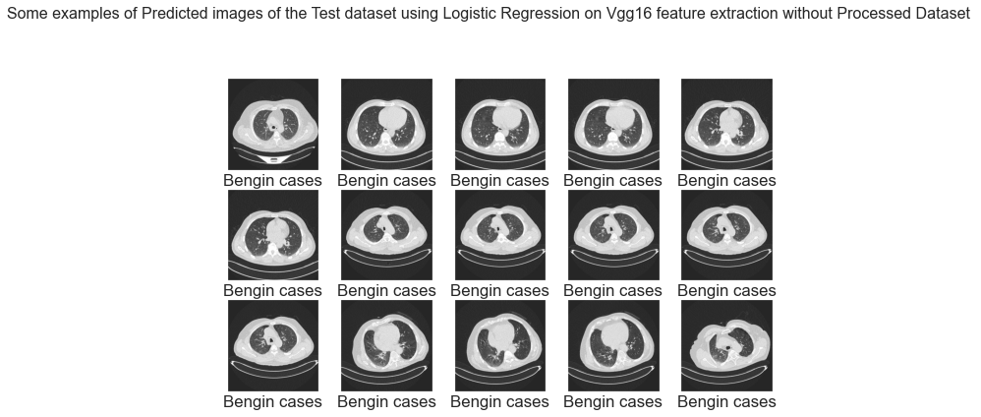

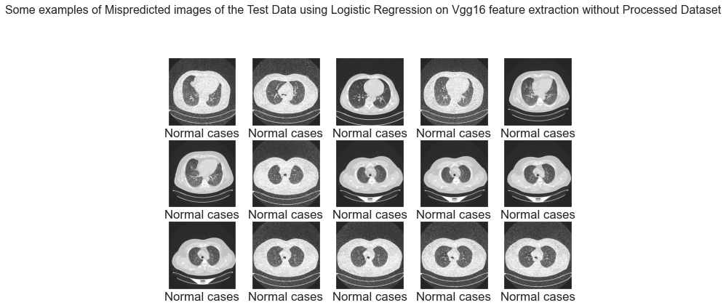

**Random Forest Classifier on Vgg16 feature extraction without Processed Dataset**

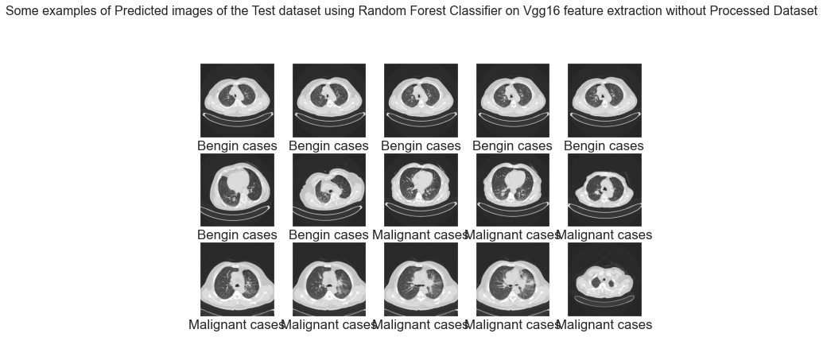

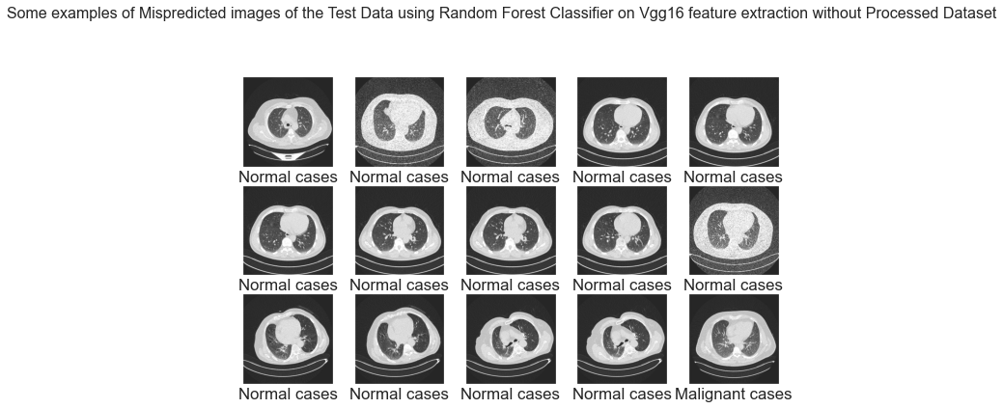

**BENIGN CASE CLASSIFICATION RESULTS**

|  |  |  |  |  |  |  |  |  |  |  |  |  |
| --- | --- | --- | --- | --- | --- | --- | --- | --- | --- | --- | --- | --- |
|  | **Processed Dataset** | | | **Without Processed Dataset** | | | **Vgg16 Feature Extraction with Processed Dataset** | | | **Vgg16 Feature Extraction Without Processed Dataset** | | |
|  | **precision** | **recall** | **f1-score** | **precision** | **recall** | **f1-score** | **precision** | **recall** | **f1-score** | **precision** | **recall** | **f1-score** |
| **Decision Tree Classifier** | 0.42 | 0.38 | 0.40 | 0.29 | 0.31 | 0.30 | 0.15 | 0.38 | 0.22 | 0.27 | 0.39 | 0.32 |
| **K-Nearest Neighbors Classifier** | 0.18 | 0.35 | 0.24 | 0.22 | 0.28 | 0.25 | 0.17 | 0.38 | 0.24 | 0.15 | 0.22 | 0.18 |
| **Logistic Regression Classifier** | 0.39 | 0.73 | 0.51 | 0.29 | 0.39 | 0.33 | 0.40 | 0.69 | 0.51 | 0.37 | 0.53 | 0.43 |
| **Naive Bayes Classifier** | 0.21 | 0.42 | 0.28 | 0.07 | 0.14 | 0.10 | 1.00 | 0.12 | 0.21 | 0.17 | 0.03 | 0.05 |
| **Random Forest Classifier** | 0.48 | 0.62 | 0.54 | 0.33 | 0.14 | 0.20 | 0.47 | 0.31 | 0.37 | 0.27 | 0.19 | 0.23 |
| **Support Vector Machine Classifier** | 0.37 | 0.62 | 0.46 | 0.21 | 0.22 | 0.21 | 0.00 | 0.00 | 0.00 | 0.00 | 0.00 | 0.00 |

**MALIGNANT CASE CLASSIFICATION RESULTS**

|  |  |  |  |  |  |  |  |  |  |  |  |  |
| --- | --- | --- | --- | --- | --- | --- | --- | --- | --- | --- | --- | --- |
|  | **Processed Dataset** | | | **Without Processed Dataset** | | | **Vgg16 Feature Extraction with Processed Dataset** | | | **Vgg16 Feature Extraction Without Processed Dataset** | | |
|  | **precision** | **recall** | **f1-score** | **precision** | **recall** | **f1-score** | **precision** | **recall** | **f1-score** | **precision** | **recall** | **f1-score** |
| **Decision Tree Classifier** | 0.73 | 0.74 | 0.73 | 0.75 | 0.77 | 0.76 | 0.84 | 0.70 | 0.77 | 0.80 | 0.81 | 0.80 |
| **K-Nearest Neighbors Classifier** | 0.87 | 0.78 | 0.82 | 0.80 | 0.77 | 0.78 | 0.91 | 0.79 | 0.85 | 0.98 | 0.85 | 0.91 |
| **Logistic Regression Classifier** | 0.95 | 0.74 | 0.83 | 0.84 | 0.88 | 0.86 | 0.91 | 0.84 | 0.87 | 0.95 | 0.99 | 0.97 |
| **Naive Bayes Classifier** | 0.89 | 0.60 | 0.72 | 0.91 | 0.63 | 0.75 | 0.64 | 0.99 | 0.78 | 0.67 | 0.99 | 0.80 |
| **Random Forest Classifier** | 0.83 | 0.81 | 0.82 | 0.78 | 0.86 | 0.82 | 0.84 | 0.87 | 0.85 | 0.94 | 0.99 | 0.97 |
| **Support Vector Machine Classifier** | 0.90 | 0.83 | 0.87 | 0.87 | 0.89 | 0.88 | 0.87 | 0.84 | 0.85 | 0.98 | 1.00 | 0.99 |

**NORMAL CASE CLASSIFICATION RESULTS**

|  |  |  |  |  |  |  |  |  |  |  |  |  |
| --- | --- | --- | --- | --- | --- | --- | --- | --- | --- | --- | --- | --- |
|  | **Processed Dataset** | | | **Without Processed Dataset** | | | **Vgg16 Feature Extraction with Processed Dataset** | | | **Vgg16 Feature Extraction Without Processed Dataset** | | |
|  | **precision** | **recall** | **f1-score** | **precision** | **recall** | **f1-score** | **precision** | **recall** | **f1-score** | **precision** | **recall** | **f1-score** |
| **Decision Tree Classifier** | 0.66 | 0.66 | 0.66 | 0.62 | 0.60 | 0.61 | 0.60 | 0.54 | 0.57 | 0.54 | 0.46 | 0.49 |
| **K-Nearest Neighbors Classifier** | 0.69 | 0.67 | 0.68 | 0.61 | 0.60 | 0.60 | 0.67 | 0.60 | 0.63 | 0.65 | 0.68 | 0.66 |
| **Logistic Regression Classifier** | 0.69 | 0.77 | 0.73 | 0.69 | 0.58 | 0.63 | 0.77 | 0.74 | 0.75 | 0.82 | 0.67 | 0.74 |
| **Naive Bayes Classifier** | 0.48 | 0.60 | 0.53 | 0.59 | 0.68 | 0.63 | 0.93 | 0.40 | 0.56 | 0.79 | 0.47 | 0.59 |
| **Random Forest Classifier** | 0.72 | 0.71 | 0.71 | 0.61 | 0.62 | 0.62 | 0.78 | 0.79 | 0.79 | 0.76 | 0.78 | 0.77 |
| **Support Vector Machine Classifier** | 0.75 | 0.73 | 0.74 | 0.69 | 0.66 | 0.67 | 0.74 | 0.92 | 0.82 | 0.77 | 0.97 | 0.86 |

**Deep Learning Approach**

**Deep learning Approach Accuracy Table**

|  |  |  |  |  |  |
| --- | --- | --- | --- | --- | --- |
|  | **Training Loss** | **Validation Loss** | **Training Accuracy** | **Validation Accuracy** | **Accuracy Score** |
| **CNN with Processed Dataset** | 2.5199e-04 | 0.1237 | 1.0000 | 0.9742 | 0.75 |
| **CNN without Processed Dataset** | 4.6185e-04 | 0.0019 | 1.0000 | 1.0000 | 0.71 |
| **Vgg16 feature extraction with Processed Dataset** | 0.0030 | 0.1933 | 1.0000 | 0.9548 | 0.80 |
| **Vgg16 feature extraction without Processed Dataset** | 0.0837 | 0.2022 | 0.9707 | 0.9351 | 0.84 |

**Accuracy Curve and Loss Curve for CNN model on Processed Dataset**

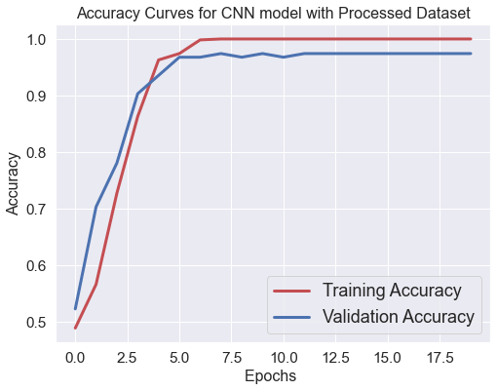

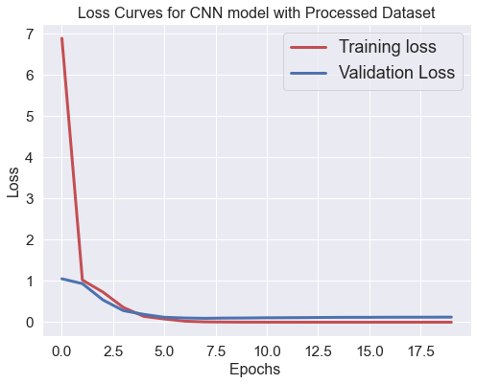

**Accuracy Curve and Loss Curve for CNN model on without Processed Dataset**

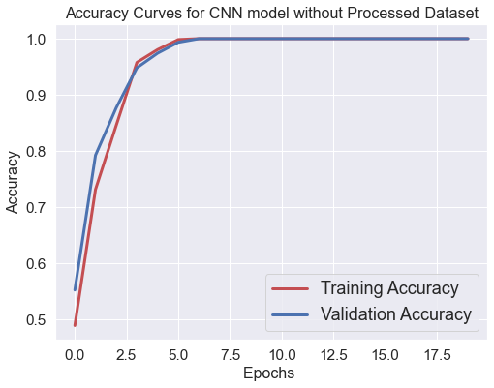

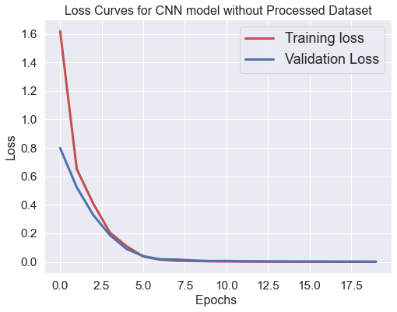

**Accuracy Curve and Loss Curve for VGG16 Feature extraction with processed Dataset**

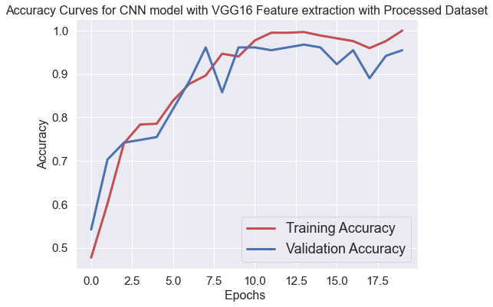

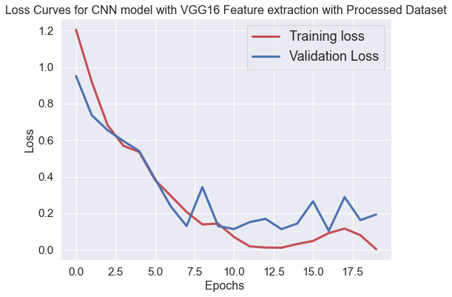

**Accuracy Curve and Loss Curve for VGG16 Feature extraction without processed Dataset**

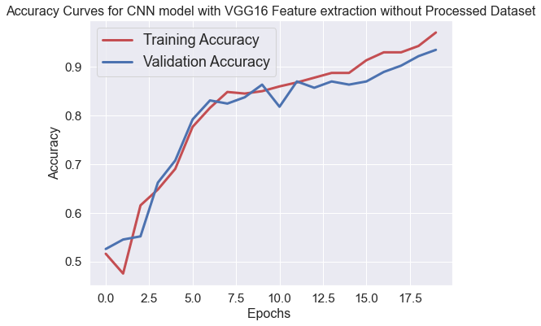

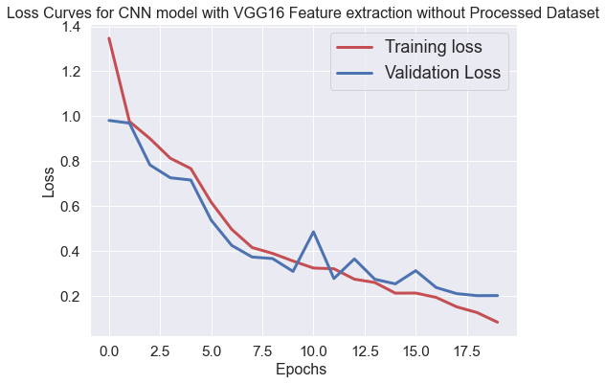

**Deep learning Classification Results**

|  |  |  |  |  |  |  |  |  |  |  |  |  |
| --- | --- | --- | --- | --- | --- | --- | --- | --- | --- | --- | --- | --- |
|  | **CNN with Processed Dataset** | | | **CNN without Processed Dataset** | | | **Vgg16 feature Extraction with Processed Dataset** | | | **Vgg16 feature Extraction without Processed Dataset** | | |
|  | **precision** | **recall** | **f1-score** | **precision** | **recall** | **f1-score** | **precision** | **recall** | **f1-score** | **precision** | **recall** | **f1-score** |
| **BENIGN CASE CLASSIFICATION RESULTS** | 0.21 | 0.46 | 0.29 | 0.39 | 0.31 | 0.34 | 0.26 | 0.46 | 0.33 | 0.29 | 0.14 | 0.19 |
| **MALIGNANT CASE CLASSIFICATION RESULTS** | 0.94 | 0.88 | 0.91 | 0.76 | 0.92 | 0.83 | 0.89 | 0.96 | 0.92 | 0.96 | 0.96 | 0.96 |
| **NORMAL CASE CLASSIFICATION RESULTS** | 0.76 | 0.64 | 0.70 | 0.69 | 0.53 | 0.60 | 0.88 | 0.63 | 0.74 | 0.76 | 0.87 | 0.81 |

**Deep learning Image Classification**

**CNN with Processed Dataset**

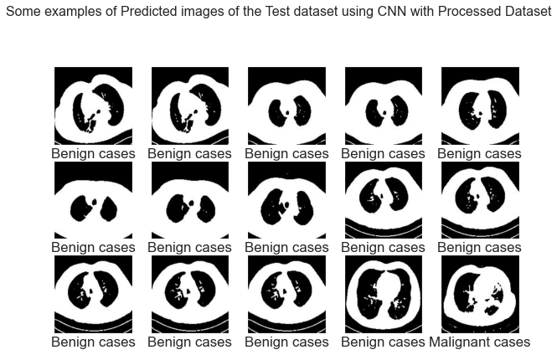

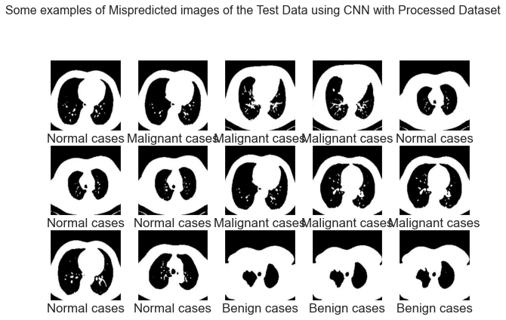

**CNN without Processed Dataset**

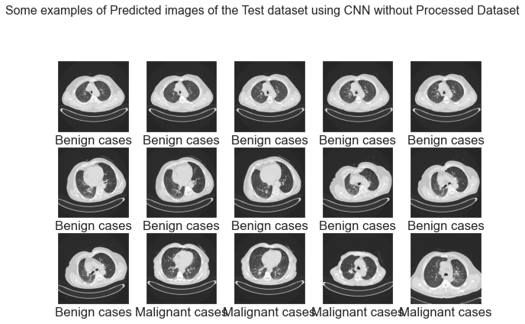

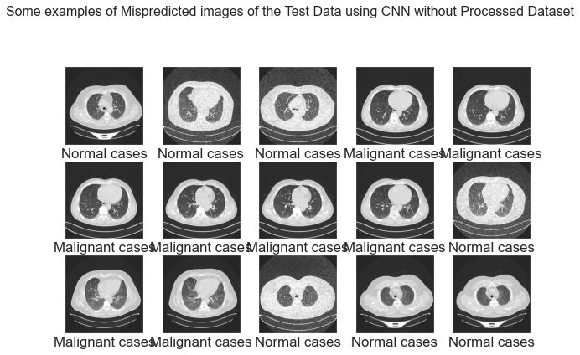

**CNN with Vgg16 feature Extraction on Processed Dataset**

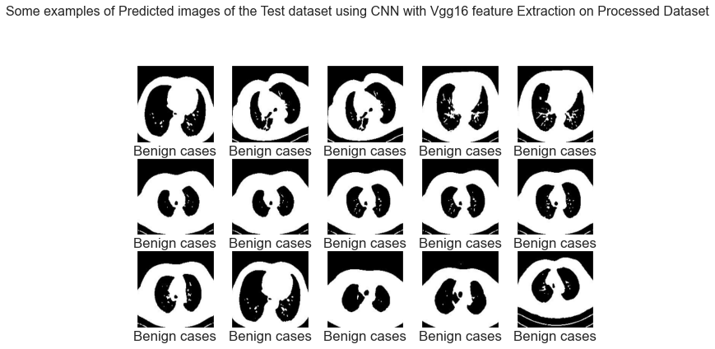

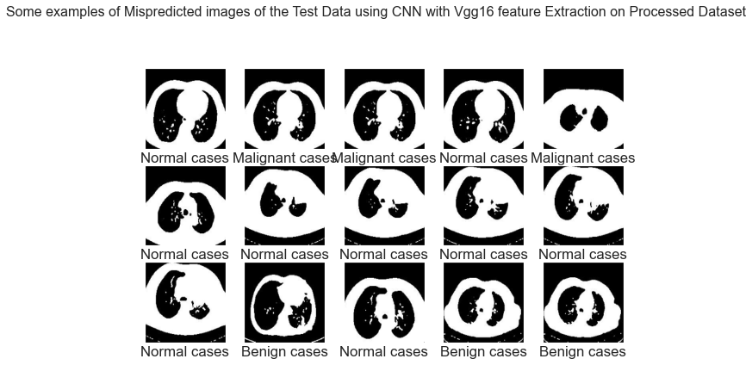

**CNN with Vgg16 feature Extraction without Processed Dataset**

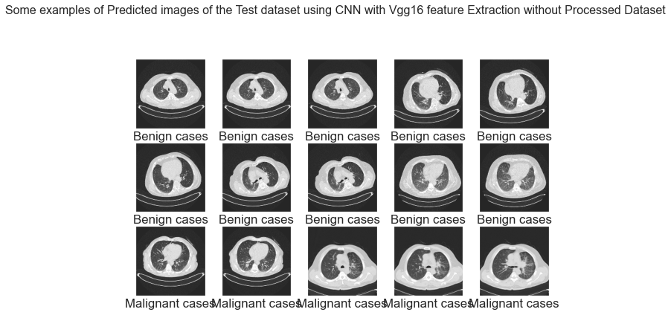

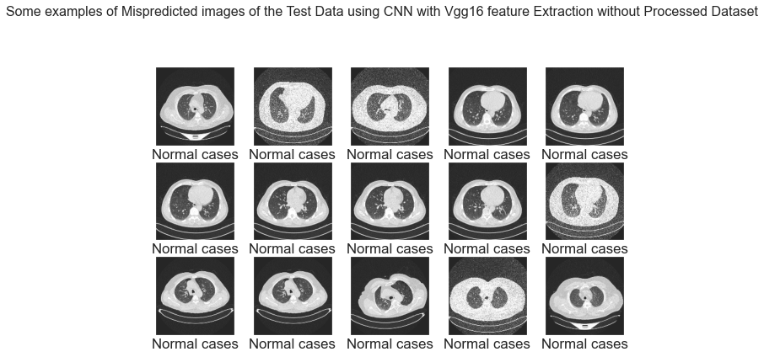

**macro avg**

|  |  |  |  |  |  |  |  |  |  |  |  |  |
| --- | --- | --- | --- | --- | --- | --- | --- | --- | --- | --- | --- | --- |
|  | **Processed Dataset** | | | **Without Processed Dataset** | | | **Vgg16 Feature Extraction with Processed Dataset** | | | **Vgg16 Feature Extraction Without Processed Dataset** | | |
|  | **Benign Cases** | **Malignant Cases** | **Normal Cases** | **Benign Cases** | **Malignant Cases** | **Normal Cases** | **Benign Cases** | **Malignant Cases** | **Normal Cases** | **Benign Cases** | **Malignant Cases** | **Normal Cases** |
| **Decision Tree Classifier** | 0.60 | 0.59 | 0.60 | 0.56 | 0.56 | 0.56 | 0.53 | 0.54 | 0.52 | 0.53 | 0.55 | 0.54 |
| **K-Nearest Neighbors Classifier** | 0.58 | 0.60 | 0.58 | 0.54 | 0.55 | 0.55 | 0.58 | 0.59 | 0.57 | 0.59 | 0.58 | 0.59 |
| **Logistic Regression Classifier** | 0.67 | 0.75 | 0.69 | 0.61 | 0.62 | 0.61 | 0.69 | 0.76 | 0.71 | 0.71 | 0.73 | 0.71 |
| **Naive Bayes Classifier** | 0.53 | 0.53 | 0.51 | 0.53 | 0.48 | 0.49 | 0.85 | 0.50 | 0.51 | 0.54 | 0.50 | 0.48 |
| **Random Forest Classifier** | 0.68 | 0.71 | 0.69 | 0.57 | 0.54 | 0.54 | 0.70 | 0.66 | 0.67 | 0.66 | 0.65 | 0.65 |
| **Support Vector Machine Classifier** | 0.67 | 0.72 | 0.69 | 0.59 | 0.59 | 0.59 | 0.54 | 0.59 | 0.56 | 0.58 | 0.66 | 0.62 |

|  |  |  |  |  |  |  |  |  |  |  |  |  |
| --- | --- | --- | --- | --- | --- | --- | --- | --- | --- | --- | --- | --- |
|  | **Processed Dataset** | | | **Without Processed Dataset** | | | **Vgg16 Feature Extraction with Processed Dataset** | | | **Vgg16 Feature Extraction Without Processed Dataset** | | |
|  | **Benign Cases** | **Malignant Cases** | **Normal Cases** | **Benign Cases** | **Malignant Cases** | **Normal Cases** | **Benign Cases** | **Malignant Cases** | **Normal Cases** | **Benign Cases** | **Malignant Cases** | **Normal Cases** |
| **Decision Tree Classifier** | 0.68 | 0.68 | 0.68 |  |  |  |  |  |  |  |  |  |
| **K-Nearest Neighbors Classifier** | 0.75 | 0.70 | 0.72 |  |  |  |  |  |  |  |  |  |
| **Logistic Regression Classifier** | 0.80 | 0.75 | 0.76 |  |  |  |  |  |  |  |  |  |
| **Naive Bayes Classifier** | 0.68 | 0.58 | 0.61 |  |  |  |  |  |  |  |  |  |
| **Random Forest Classifier** | 0.76 | 0.75 | 0.76 |  |  |  |  |  |  |  |  |  |
| **Support Vector Machine Classifier** | 0.80 | 0.77 | 0.78 |  |  |  |  |  |  |  |  |  |